Test Program:

1. in-fix sequences to minimum

(There is a spelling mistake, “Equation”, not “Eqaution”)

* 1. 2+4\*8-5/3 = 2+4\*8-5/3

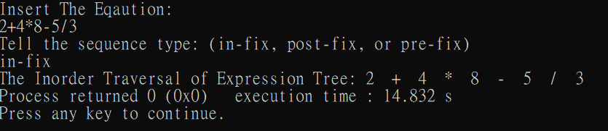

* 1. (1+1)\*2-2+4-5 = 1\*2+1\*2-2+4-5

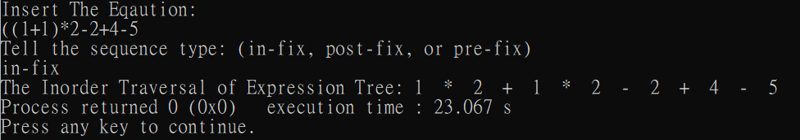

* 1. ((1+1)\*2)\*3+4 = 1\*2\*3+1\*2\*3+4

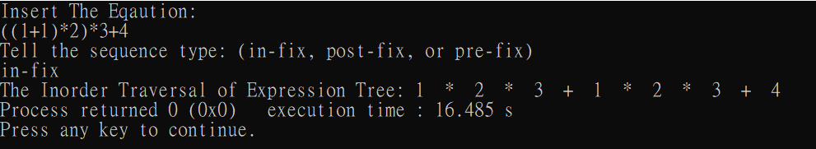

* 1. (1+2)\*3\*(4+5) = 1\*3\*4+2\*3\*4+1\*3\*5+2\*3\*5

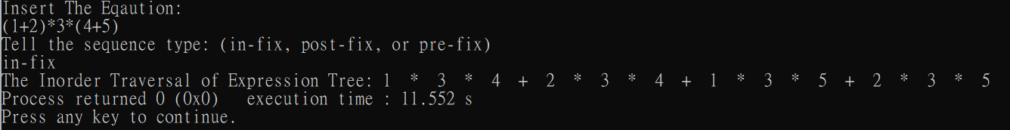

1. post-fix to in-fix minimum
2. 24+8\*53/ = actually I think this is not a complete post-fix

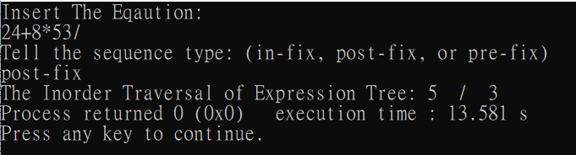

instead: 24+8\*53/- = 2\*8+4\*8-5/3

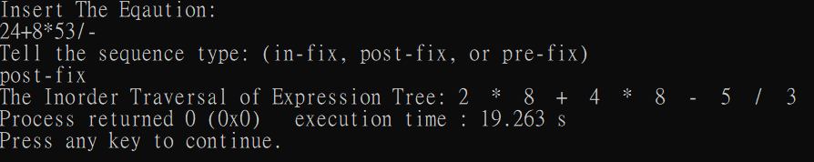

1. 11+2\*2-45\*- = 1\*2+1\*2-2-4\*5

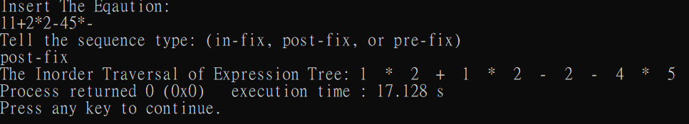

1. 11\*23+/ = 1\*1/2+1\*1/3

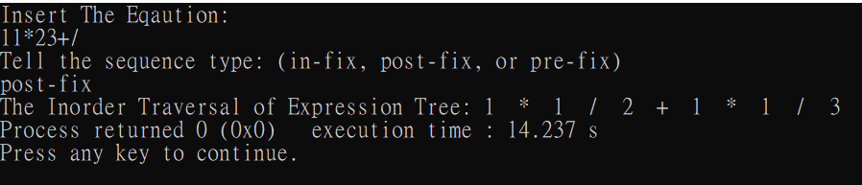

1. 12\*3/45+- = 1\*2/3-4-5

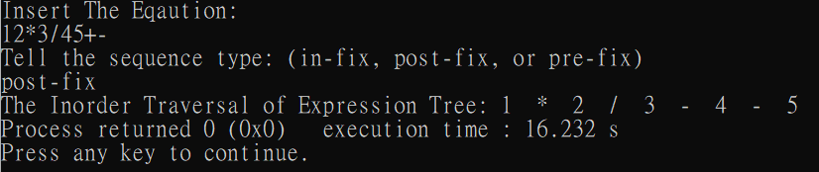

1. pre-fix to in-fix minimum
   1. /+12-34 = 1/3+2/3-1/4-2/4

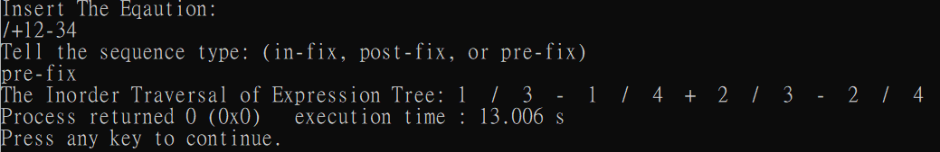

* 1. \*\*11/+345 = 1\*1\*3/5+1\*1\*4/5

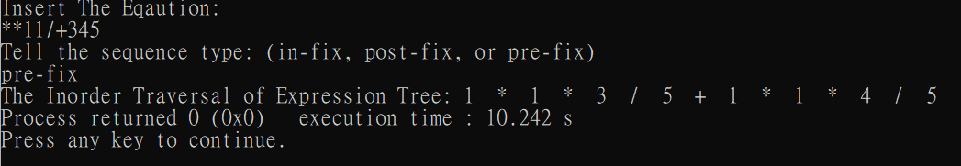

* 1. /\*11+23 = 1\*1/2 +1\*1/3

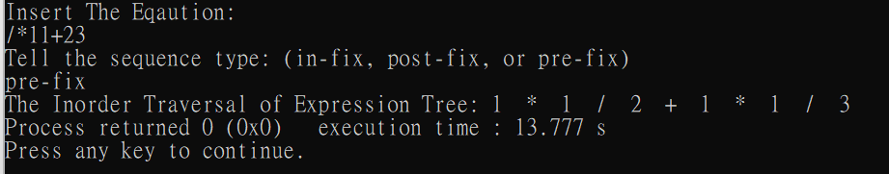

* 1. - - 12/+345 = 1-2-3/5-4/5

